

TeaMs App

Author: Tyler Lu

Contents

1. Download files from VSO 2

2. Create Teams App package 2

2.1. Update manifest.json 2

2.2. Create Teams App package 2

3. Manage Team 3

3.1. Side-load the Teams App 3

3.2. Add the Metric Input tab 4

3.3. Add the Idea Board tab 5

# Create Teams App package

## Update manifest.json

1. Open */Files/TeamsAppPackage/manifest.json* with a text editor.
2. Replace the following 2 placeholder with the corresponding values you got in previous guides

* <MicrosoftAppId>: the App Id of the Microsoft App registered when creating the Bot

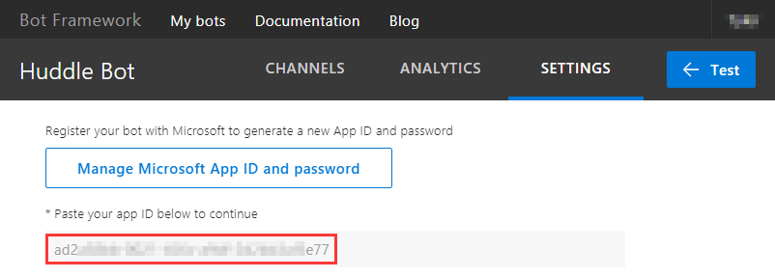

* <MetricWebAppDomain>: the domain of the Metric Web App

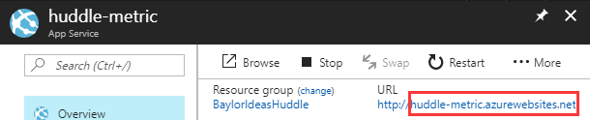

1. Save the changes.

## Create Teams App package

Zip the files in */Files/TeamsAppPackage* folder.

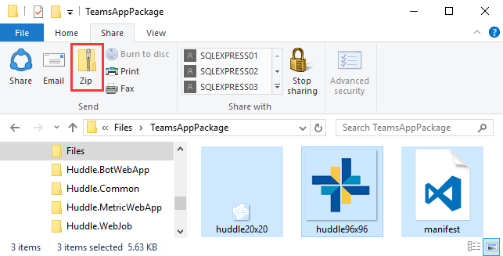

Name it HuddleTeamsApp.zip.

# Manage Team

## Side-load the Teams App

Follow the steps below to side the Teams App.

1. Right-click a team in Microsoft Teams, then click Manage team

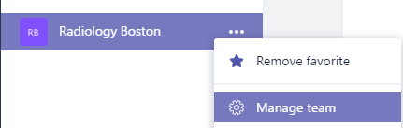

1. Click the **Bots** tab

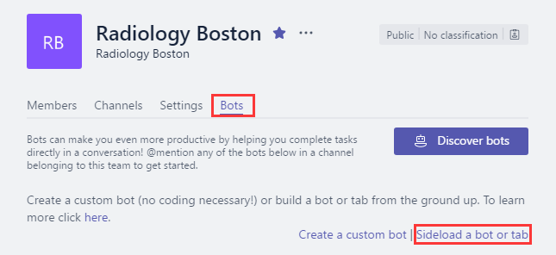

1. Then click **Sideload a bot or tab**.
2. Select the *HuddleTeamsApp.zip*.

## Add the Metric Input tab

1. Click a team.



1. Click +

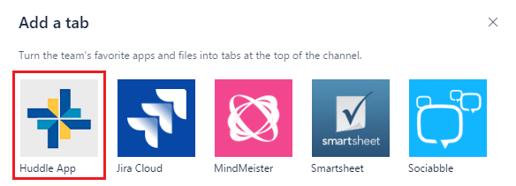

1. Click **Huddle App**.

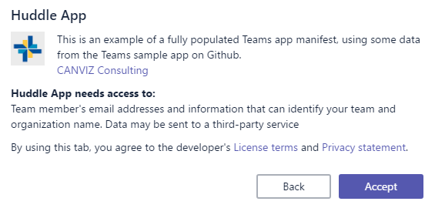

1. Click Accept.

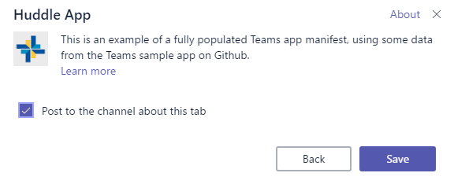

1. Click **Save**.

## Start 1:1 conversation with the Bot

Find the URL of Microsoft Teams Channel of the Bot, then open it in your browser:

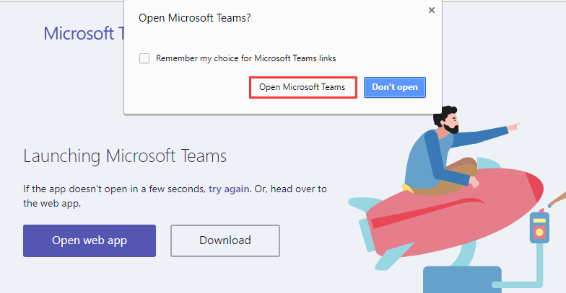

Click **Open Microsoft Teams**.

Note: Another way to start 1:1 talk is using the MicrosoftAppId of the Bot:

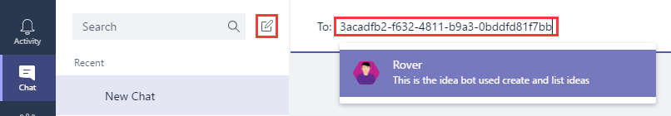

## Add the Idea Board tab

1. Click a team.

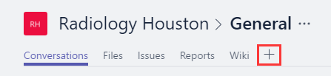

1. Click +

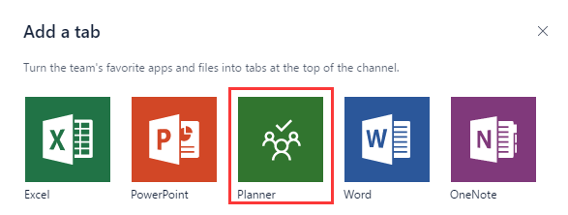

1. Click Planner.
2. Sign in with the work account.

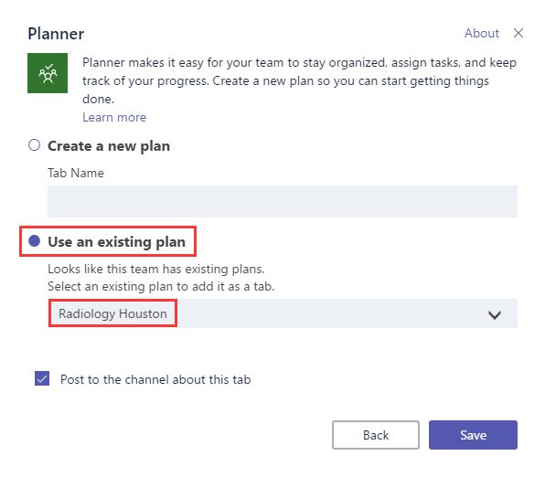

Choose **Use an existing plan**, then select the plan which has the same name with the team.

1. Click **Save**.

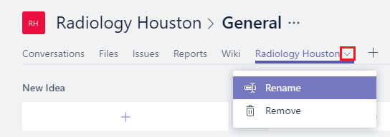

1. Click the dropdown icon, then click **Rename**.

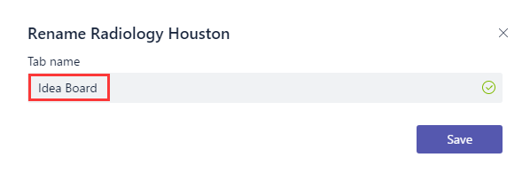

Input: Idea Board

1. Click **Save**.